VINH LONG UNIVERSITY OF TECHNOLOGY EDUCATION

**PRACTICE CENTER**

TEST PROJECT

PRACTICAL SKILLS

MODULE 4: IT SOFTWARE SOLUTIONS

MAJORS: SOFTWARE TECHNOLOGY

**Exam Paper Code: ITSS01**

|  |  |
| --- | --- |
| **SCHOOL LEADERSHIP** | **CHIEF SUBCOMMITTEE ON EXAM DEVELOPMENT** |

**Vinh Long, month 12/2020**

**GUIDE CONTESTANTS**

**Module 4: IT Software Solutions**

**Time:**

* Preparation Time: 05 minutes
* Time Duration: 150 minutes
* Break Time: 10 minutes

**Scores:**

|  |  |  |
| --- | --- | --- |
| **Exam content** | | **Marks** |
| 1 | Creating the Database | 5 |
| 2 | Importing Database Structure | 5 |
| 3 | Managing Current Inventory | 40 |
| 4 | Purchase Orders | 50 |
| **Total Marks** | | **100** |

**Candidates are required to note:**

* Ensure safety standards of health and computer
* Do the test independently without discussing while doing the test
* Comply with regulations of exam room and proctor’s instructions
* Fill the information in the form
* Complete all requirements in the content of the exam
* Do not use documents, the Internet and other communication devices during the assignment
* If the exam does not have special requirement for the file name and storage location, contestants save all exam file name in the folder as following format**: D:\WorkSkills\IT Software Solutions**

***<Student’s Name>_<*** ***Student code >[.<*** ***extension >]***

**CONTENT OF THE TEST**

This Test Project proposal consists of the following documentation/files:

1. ITSS01.pdf (Session instructions)

2. ITSS01-MsSQL.sql (SQL Script to create tables with data for Microsoft SQL)

**INTRODUCTION**

This session arms to evaluate your capabilities in the manipulation of knowledge related to the windows-based application development.

Kazan Neft has been expanding into new locations both inside Russia and abroad and as such expansions go, there’s a growing need to organize its inventory and all the assets it owns and operates. As a part of the maintenance management and enterprise asset management system for Kazan Neft, you will develop the following section for the administrators on the Windows platform:

|  |
| --- |
| **Purchase Order Management: Controls purchasing of products and services from external suppliers** |

**DESCRIPTION OF TASKS**

While developing the test project, please make sure the deliverables conform to the basic guidelines drawn out by different departments at Kazan Neft:

* There should be consistency in using the provided style guide throughout development.
* All required software modules must have applicable and useful validation and error messages as expected by the industry.
* Offer a scrollbar if the number of records on a list or a table that do not fit in the form area comfortably. Hide scrollbars if all content can comfortably be displayed.
* The de-facto standard, ISO compliant date format is YYYY-MM-DD which will be used in this task where applicable.
* Where applicable, use comments in code to have the code more programmer-readable.
* The use of valid and proper naming conventions is expected in all material submitted.
* Any form or report once created should be displayed in the centre of the screen.
* When a form or a dialogue is in focus, operations on other forms need to be suspended.
* Provide appropriate validation and error messages throughout all parts of the system.
* The caption of Delete and Cancel buttons need to be in red to help with accidental mishaps.
* When using colors to differentiate between rows or records, there needs to be visible clarification on the screen as to what they stand for.
* The wireframe diagrams provided as part of this document are only suggestions and the solution produced does not have to be, in any way, mirror what has been pictured.
* Time management is critical to the success of any project and so it is expected of all deliverables to be complete and operational upon delivery.

**INSTRUCTIONS**

1. **Creating the Database**

Create a database by the name of “ITSS01DATA” in your desired RDBMS Platform (Microsoft SQL Server). This will be the main and only database you will use in this session. In case you are given a database by the same name, you should use the database provided by the administrators.

1. **Importing Database Structure**

Depending on your preferred RDBMS platform, a SQL scripts is made available. The said scripts consist of the database structure and data required to complete the tasks. The data needs to be imported to the database created for this session named “ITSS01”.

As instructed by the designers, the database structure provided for the purpose of this section cannot be altered. This applies to removal of tables, adding or deleting any fields on the tables or of change in their data types.

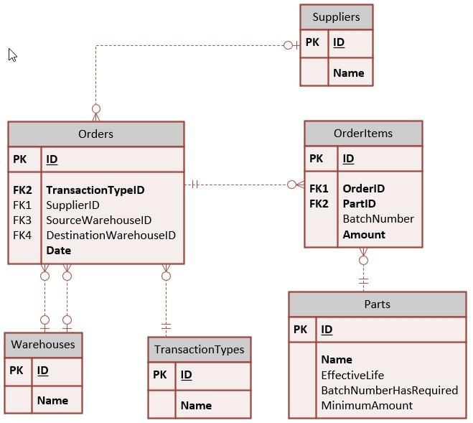

To help further perceive the thinking behind the structure of the database, the database designers provide an Entity-Relationship Diagram (ERD). The aforementioned diagram explains the conceptual and representational model of data used in the database.

1. **Managing Current Inventory**

This is the main form for the application that provides a list of transactions concerning current inventory to the maintenance manager. The following is what is required for this form:

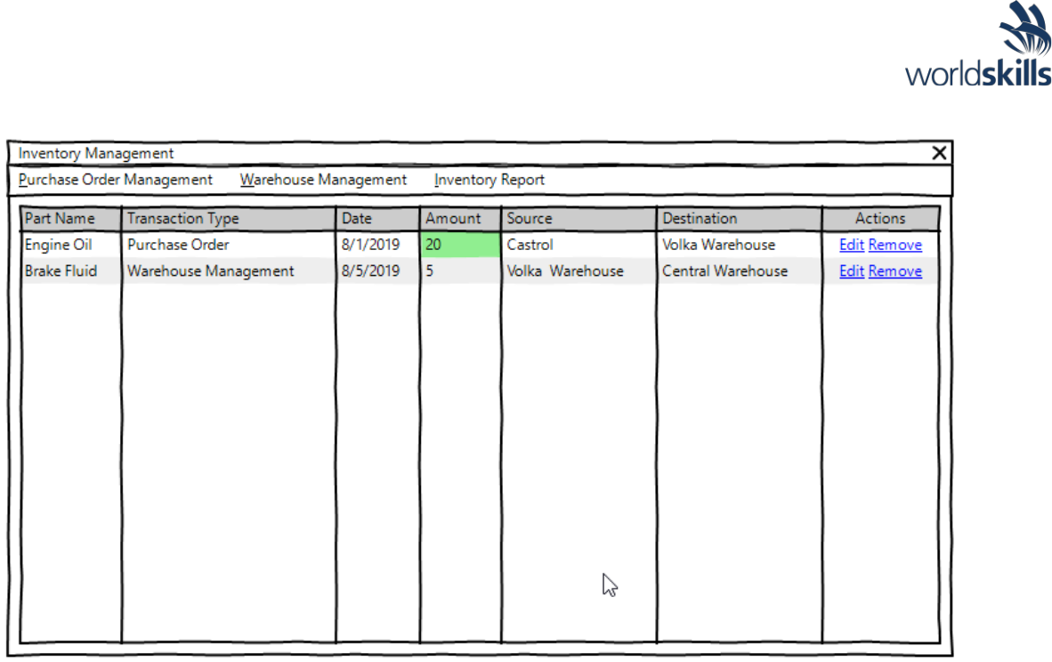

* Three buttons on the top of the form will allow the user to add purchase orders, transfer parts between warehouses and get a summary of activities performed.
* The following fields information to be made available for each of the activities performed on the inventory system:
* Part Name, Transaction Type, Transaction Date, Amount, Source, Destination
* The order in which the records are displayed needs to be organized as follows:
* Primary sorting needs to be applied on the date of the transaction where the oldest come first.
* In case the transactions have the same date, the purchase orders get higher priority.
* The user may use the list headers to change the display order:
* *By clicking once on the header of any of the fields, the user can switch between descending, and ascending sorting of the said field and can also cancel the user-defined sort order.*
* *An arrow on the left of the header title displays the sort order if a custom sort order is applied on the list.*
* The value under the field Amount needs to be differentiated using colors as suggested on the wireframe diagram.
* Used green background color for purchase order management transactions.
* Two buttons next to each record will give the user the option to remove and edit them.
* Removing a record that would make the inventory of a part in a warehouse negative should be prevented displaying an appropriate message to the user.

1. **Purchase Orders**

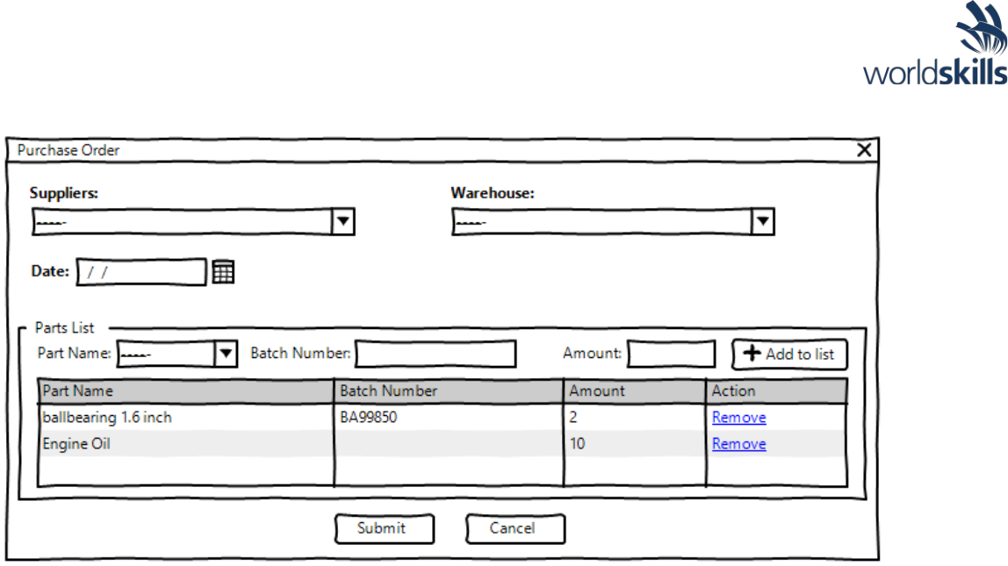

The user lands here from the main form to add new purchase orders and to edit current purchase orders:

* + To submit a purchase order the client needs to provide the following:
    - Supplier which can be selected from a list already in the database.
    - Warehouse is also populated using a predefined list from the database. o Date in which the purchase order has been completed.
    - Parts List which consists of the following:
* *Part name populated by a predefined set of values from the database.*
* *The user may use this field to look for the part they need.*
* *Batch Number is a unique number that differentiates between different productions of the part:*
* *If the part selected in the database has “BatchNumberHasRequired” set to “True”, then a batch number needs to be entered, otherwise any value entered should be ignored and should not be stored on the database.*
* *When a batch number is associated with part, the system will treat the part with different batch numbers as individual parts. The inventory for the parts is then calculated based on the pairing of part name and batch number.*
* *The list can contain multiple parts with same part name only if they have different batch numbers.*
* *Amount is the number of each part that is to be stored as part of the order:*
* *This number needs to be of positive decimal value.*
* *Same parts with different batch numbers can have different amounts on the list.*
  + At least one part needs to be added to the order for it to be valid.
  + The user may remove parts from the parts list by using a button.

When the user is editing a transaction, they may not remove parts that would make their inventory for the warehouse negative